

Practices for Secure Software Report

Table of Contents
Document Revision History 3
Client 3
Instructions 3
Developer 4
1. Algorithm Cipher 4
2. Certificate Generation 5
3. Deploy Cipher 5
4. Secure Communications 6
5. Secondary Testing 7
6. Functional Testing 8
7. Summary 9
8. Industry Standard Best Practices 10

Document Revision History

Version | Date | Author | Comments
1.0 | 08/12/2026 | Scott King

Client



Developer
Scott King

Algorithm Cipher

For the checksum requirement in Artemis Financial's application, I selected SHA-256 (Secure Hash Algorithm 256-bit). SHA-256 is a cryptographic hash function that accepts input of any practical length and produces a fixed 256-bit, or 32-byte, digest. The checksum can be used to verify data integrity because even a small change to the original data produces a different hash value. Hashing is a one-way operation rather than reversible encryption, which makes SHA-256 appropriate for verifying that transferred data has not been altered.
SHA-256 is part of the SHA-2 family and is more appropriate for current security use than older hash algorithms such as MD5 or SHA-1. In this application, Java's MessageDigest class generates the SHA-256 checksum. The verification string is converted to bytes using UTF-8 before the digest is calculated, and the resulting digest bytes are converted to hexadecimal text for display in the browser.
The secure-communications portion of the application also uses asymmetric cryptography. I generated a 2048-bit RSA public/private key pair for the self-signed certificate. Unlike symmetric encryption, which uses one shared secret key for both encryption and decryption, asymmetric cryptography uses mathematically related public and private keys. Secure random-number generation is important when cryptographic keys are created because unpredictable key material helps prevent attackers from guessing or reproducing private keys.
Modern applications normally combine multiple cryptographic technologies instead of relying on one algorithm for every security purpose. Older algorithms and smaller key sizes have become unsuitable as computing power and cryptanalysis have improved. In this project, SHA-256 provides integrity verification, RSA supports the certificate and key pair, and SSL/TLS over HTTPS protects information in transit. This layered approach provides stronger protection for Artemis Financial's client and financial information than outdated algorithms or unencrypted HTTP communication.

Certificate Generation
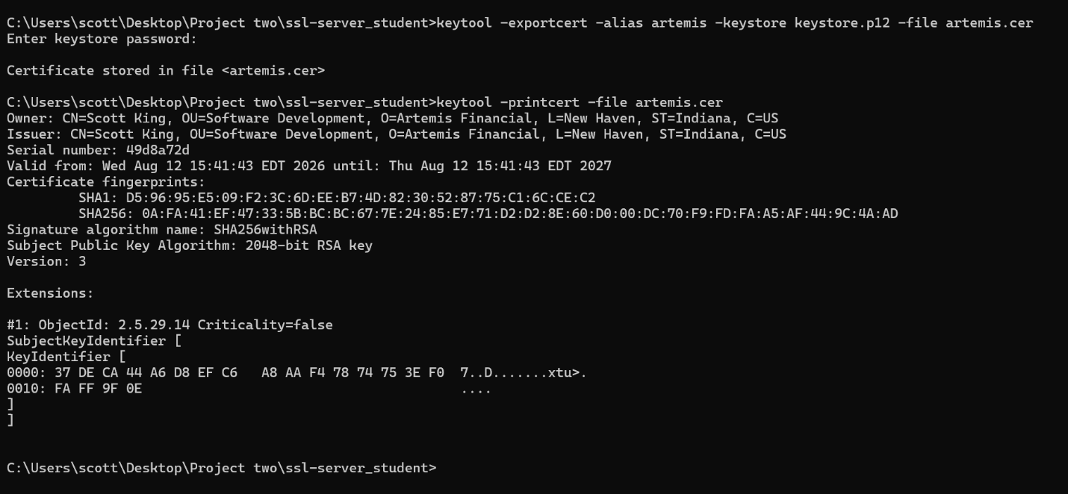

I generated a self-signed certificate for Artemis Financial using the Java Keytool. The certificate uses a 2048-bit RSA public key and SHA256withRSA signature algorithm. I exported the certificate as artemis.cer and verified its contents using Keytool. The certificate was then used with the application's PKCS12 keystore to support HTTPS communication during development and testing.

Deploy Cipher
I deployed a SHA-256 cryptographic hash algorithm in the Artemis Financial application to provide checksum verification. The application uses Java's MessageDigest class to generate a SHA-256 hash from a unique data string. The data is converted to bytes using UTF-8 and processed by SHA-256 to produce a 256-bit checksum. The resulting hash is converted into hexadecimal format and displayed by the /hash endpoint. This provides a method of verifying data integrity because any change to the original data will produce a different checksum.
For testing, I used the unique data string “Scott King - Artemis Financial Secure Communication Verification.” The application successfully generated and displayed the SHA-256 checksum, demonstrating that the cryptographic hash functionality was implemented correctly.

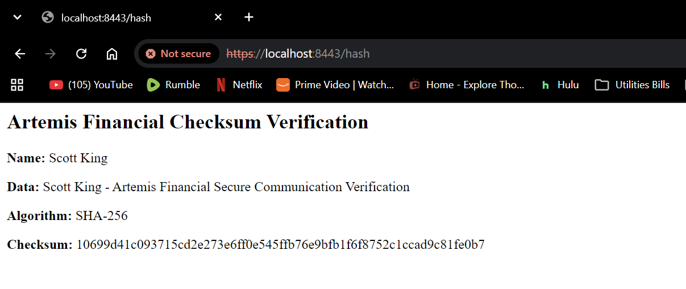
SHA-256 checksum verification generated by the refactored Artemis Financial application.

Secure Communications
I refactored the Artemis Financial application to use HTTPS instead of HTTP for secure communications. I configured the Spring Boot application to use port 8443 and enabled SSL in the application.properties file. The application uses the PKCS12 keystore containing the self-signed certificate generated for Artemis Financial. After compiling and running the refactored application, the embedded Tomcat server successfully started on port 8443 using HTTPS.
I then tested the secure connection by navigating to https://localhost:8443/hash. The application successfully loaded through HTTPS and displayed the SHA-256 checksum verification. HTTPS provides encryption for data transmitted between the client and server, helping protect financial and client information from interception or modification while it is in transit.
Because this project uses a self-signed certificate rather than a certificate issued by a publicly trusted certificate authority, the browser displays a certificate trust warning. This warning does not mean HTTPS failed. The successful HTTPS connection on port 8443 demonstrates that SSL/TLS was enabled and that the application is serving the /hash endpoint over HTTPS.

Secure Communications: The application was configured to use HTTPS on port 8443 with SSL/TLS enabled. The successful connection to https://localhost:8443/hash demonstrates that the application is using an encrypted communication channel rather than unsecured HTTP.

Secondary Testing
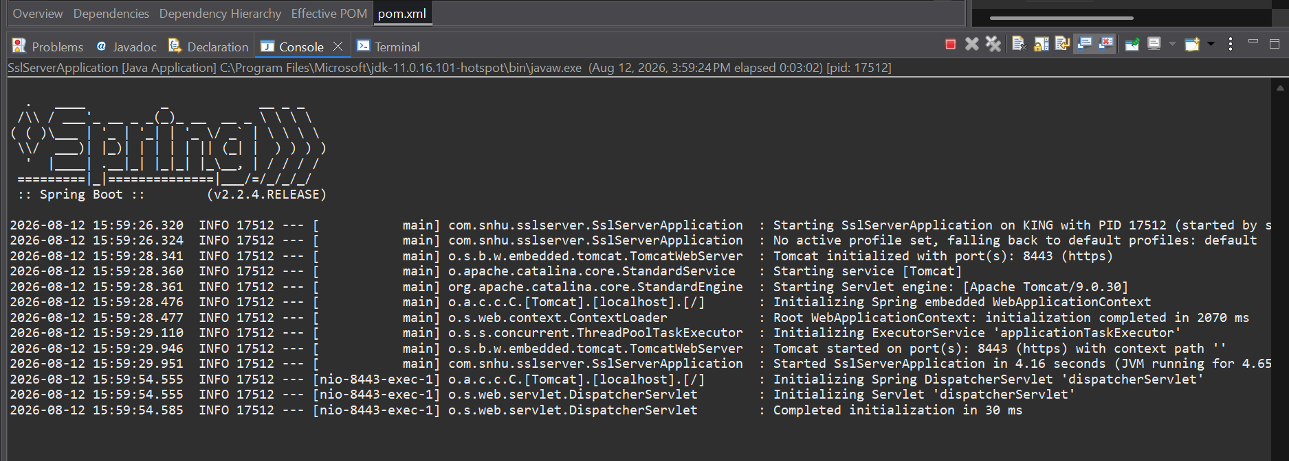
Refactored application executing successfully on HTTPS port 8443 without runtime errors.

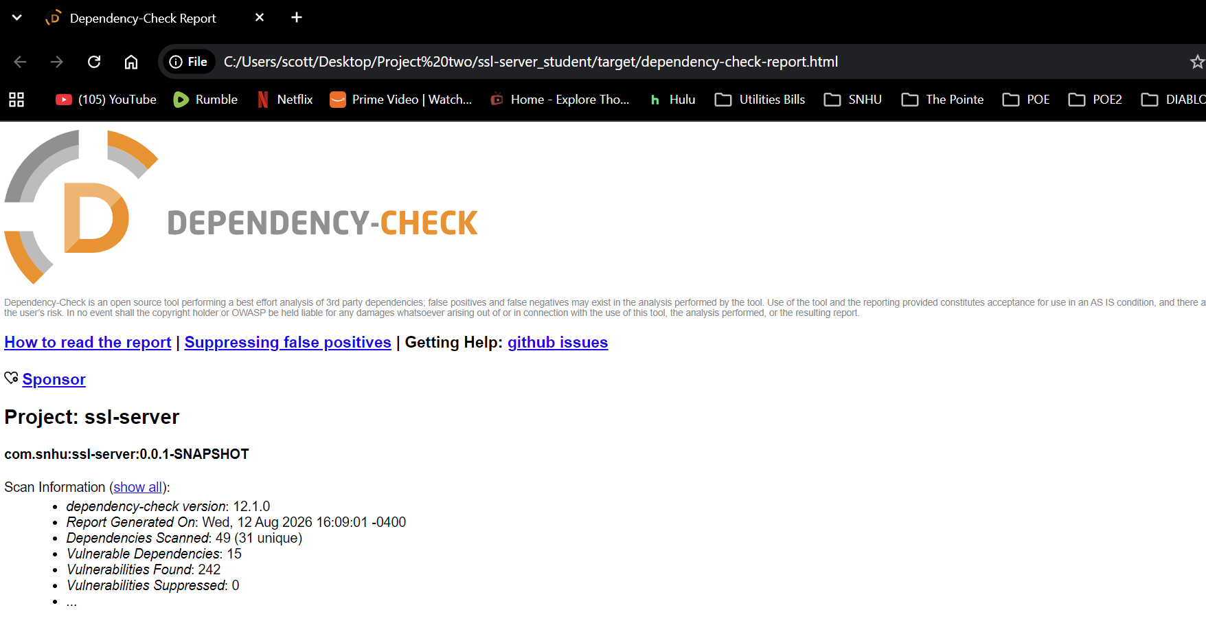
Secondary Static Testing: After completing the security refactoring, I performed a secondary static analysis using OWASP Dependency-Check version 12.1.0. The scan analyzed 49 dependencies (31 unique) and reported 15 vulnerable dependencies containing 242 known vulnerability findings. I reviewed the results specifically to determine whether the code added during my refactoring introduced additional security vulnerabilities, as required by Project Two. The SHA-256 checksum implementation uses Java's built-in MessageDigest API, and the HTTPS implementation uses the existing Spring Boot SSL/TLS capabilities and generated keystore rather than adding new third-party libraries. Therefore, the secondary testing did not identify new dependency vulnerabilities introduced by my refactoring. The remaining findings are associated with the existing legacy dependency stack supplied with the project and should be addressed through future framework and dependency modernization.

Functional Testing
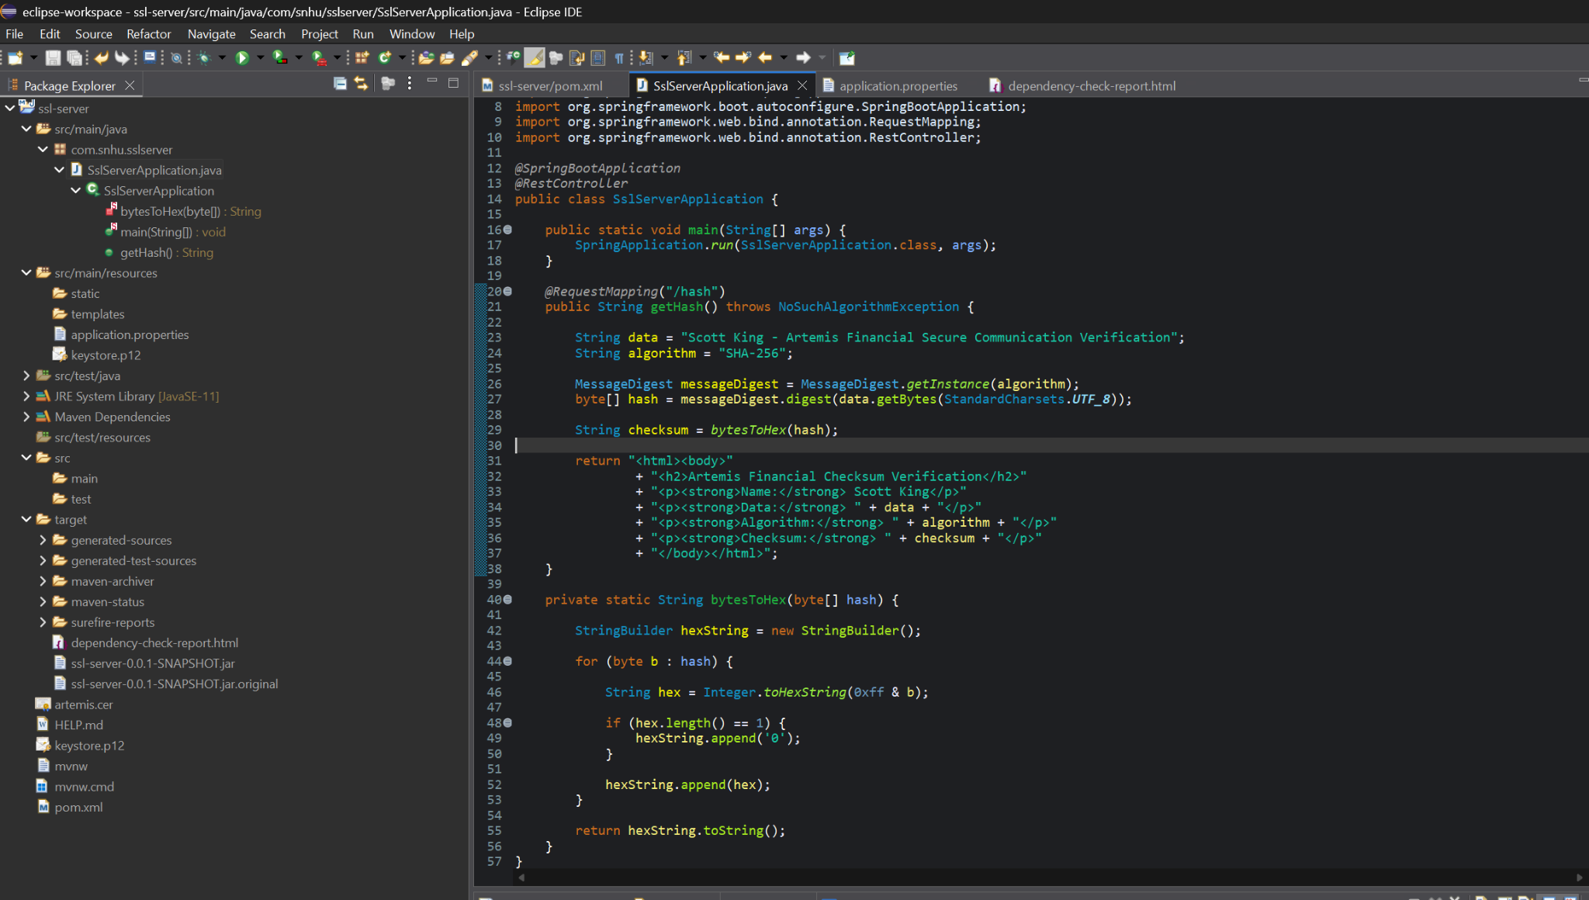



Functional Testing: I manually reviewed the refactored Java code and application configuration for syntactical, logical, and security issues. Any syntax or configuration problems encountered during refactoring were corrected before final testing. I then executed the completed application and confirmed that the Spring Boot console started the embedded Tomcat server successfully on HTTPS port 8443 without runtime errors. I also tested the /hash endpoint in the browser and verified that it returned my unique data string, the SHA-256 algorithm name, and the expected checksum. These tests confirmed that the checksum generation, hexadecimal conversion, REST endpoint, certificate configuration, and HTTPS communication worked together as intended.

Summary

The Artemis Financial application was refactored to improve data integrity and secure communications while following the Vulnerability Assessment Process Flow. Of the security areas identified in the process flow, this refactoring directly addressed Cryptography, Client/Server, APIs, Code Quality, and Code Error. Cryptography was addressed through SHA-256 checksum verification, a 2048-bit RSA key pair, and certificate-based SSL/TLS. Client/Server security was improved by replacing unsecured HTTP communication with HTTPS on port 8443. API security was addressed by implementing and testing the /hash REST endpoint over HTTPS. Code Quality and Code Error concerns were addressed through manual review, correction of syntax and configuration issues, functional testing, and secondary dependency analysis. Input Validation and Encapsulation were also considered during review; however, the newly added /hash functionality uses a fixed server-side verification string rather than accepting untrusted client input, so those areas did not require significant refactoring for this specific functionality.
Security was added in layers rather than relying on a single control. The SHA-256 checksum provides an integrity mechanism that can be used to determine whether data has changed. The self-signed certificate and PKCS12 keystore provide the cryptographic material required for SSL/TLS, while HTTPS protects information transmitted between the client and server. Together, these controls address different security concerns. The checksum helps verify the integrity of data, while HTTPS protects communications in transit and the certificate provides the identity information required to establish the encrypted connection.
After refactoring the application, I performed functional testing to verify that the application compiled and executed correctly and that the /hash endpoint generated the expected SHA-256 checksum. I also performed secondary static testing using OWASP Dependency-Check. The scan identified known vulnerabilities associated with dependencies in the existing project framework. The security functionality I added used Java's existing security APIs and application configuration rather than introducing additional third-party libraries. These results demonstrate why dependency scanning should remain part of the software development lifecycle even after an application is functioning correctly.
Overall, the refactoring process increased the security of the Artemis Financial application by combining integrity verification, certificate-based HTTPS communication, manual code review, functional testing, and automated dependency analysis. The completed application runs successfully over HTTPS and produces the required SHA-256 checksum without introducing new third-party dependencies. Security testing should continue throughout future development because vulnerability and dependency risks change over time. Using multiple layers of protection reduces reliance on any single control and provides Artemis Financial with a stronger foundation for protecting client financial information.

Industry Standard Best Practices

Industry-standard secure coding practices were applied throughout the refactoring of the Artemis Financial application. I used established cryptographic algorithms and Java security APIs rather than attempting to create a custom cryptographic solution. SHA-256 was implemented through Java's MessageDigest class to provide checksum verification and protect data integrity. A 2048-bit RSA key pair and self-signed certificate were generated for the development environment, and SSL/TLS was enabled so that the application communicates through HTTPS instead of unsecured HTTP. These choices follow the principle of using established and tested security mechanisms rather than developing proprietary cryptographic methods.
I also applied a defense-in-depth approach by using multiple security controls for different purposes. SHA-256 provides integrity verification, while HTTPS protects information transmitted between the client and server. The certificate and private key are maintained through a keystore rather than being embedded directly into the Java source code. Functional testing was performed after refactoring to verify that the security changes did not prevent the application from operating correctly. OWASP Dependency-Check was also used as a secondary static testing method to identify known vulnerabilities associated with third-party dependencies. The results demonstrate the importance of continuing to monitor and update dependencies throughout the software development lifecycle.
Applying secure coding best practices provides value beyond protecting the application itself. Artemis Financial handles sensitive client and financial information, so weaknesses in the application could result in unauthorized access, loss of data integrity, disclosure of confidential information, reputational damage, and financial consequences. Building security into the development and testing process helps identify weaknesses before software is released and makes future security maintenance more manageable. Regular code review, dependency scanning, secure communication, established cryptographic standards, and repeated testing can reduce risk while helping Artemis Financial maintain the confidentiality and integrity of its clients' information.
Security should therefore be treated as an ongoing part of the software development lifecycle rather than a one-time task. Future development should continue to review dependencies, replace outdated components when supported versions become available, perform static and functional security testing after changes, protect cryptographic keys and credentials, and use certificates issued by a trusted certificate authority when deploying the application in a production environment.

Code Files Included in Refactored ZIP
• SslServerApplication.java - Implements the /hash REST endpoint, SHA-256 MessageDigest checksum generation, UTF-8 byte conversion, and hexadecimal output.
• application.properties - Enables SSL/TLS, configures HTTPS on port 8443, and points Spring Boot to the PKCS12 keystore.
• pom.xml - Defines the Spring Boot project and integrates OWASP Dependency-Check 12.1.0 for secondary static testing.
• keystore.p12 - Stores the self-signed certificate and RSA private key used by the HTTPS configuration.
• artemis.cer - Exported public certificate used as evidence of certificate generation.
• target/dependency-check-report.html - Generated OWASP Dependency-Check report documenting the secondary static-test results.

